# More Exercises: HTML and CSS Overview, HTML Structure

Problems for exercises and homework for the ["HTML and CSS" course @ SoftUni](https://softuni.bg/courses/web-fundamentals-html5). Submit your solutions in the SoftUni judge system at <https://judge.softuni.bg/Contests/396/HTML-and-CSS-More-Exercises>.

## Create Header

Create a Web Page like the screenshot below:





Create two files: "**create-header.html**"and"**create-header.css**"

Use **semantic HTML** to create the HTML page.

### Constraints

* <body>
  + Font-family: "Lato", sans-serif;
  + Text color: #ffffff;
* <header>with **class="container"**
  + Center the container
  + Padding: 0 10px;
  + Background:url(background-image.jpg) no-repeat center center;
  + Background size: cover;
  + Height: 800px;
  + Text center
* <h1>for heading
  + Text size: 80px;
  + Padding: 80px 0;
  + Letter spacing: 8px;
  + Transform the heading text to **uppercase** with CSS (see <http://www.w3schools.com/cssref/pr_text_text-transform.asp>).
* Paragraphfor the text
  + Text size: 27px;
  + Font weigth: 100;
  + Margin: 20px;
  + Escape the quotes using &quot;
* <button>with class **btn** for button
  + Text color: #ffffff;
  + Background: none;
  + Border: 5px solid #ffffff;
  + Border radius: 15px;
  + Margin top: 40px;
  + Padding: 15px 45px;
  + Text size: 16px;
* **Button** on hover
  + Background: #000;
  + Border color: #000;
  + Cursor: **pointer;**

### Hints

Reset the CSS margins and paddings, like it is explained here: <https://css-tricks.com/reset-all-margins-padding/>.

## Create Content

Create a Web Page like the following.

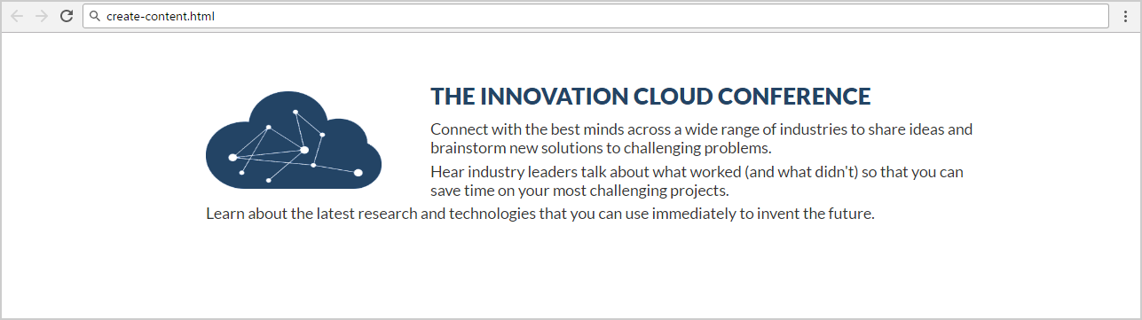

Create two files: "**create-content.html**" and "**create-content.css**"

### Constraints

* Font-family: "Lato", sans-serif;
* <main>as a **container**
  + Margin: 50px 200px;
  + Max width: 1060px;
  + Padding: 0 10px;
* <h2>for heading
  + Text color: #234465;
  + Margin: 10px;
* Paragraph
  + Text size: 16px;
  + Text color: #333333;
  + Margin bottom:5px;
  + Letter spacing: 0;
  + Width:800px;
* Image
  + Align the image on the left side.
  + Width: 180px;
  + Height: 100px;
  + Margin: 10px 50px 0 0;

## Book Story

* Create a Web Page like the following using **Book-Story.txt**.

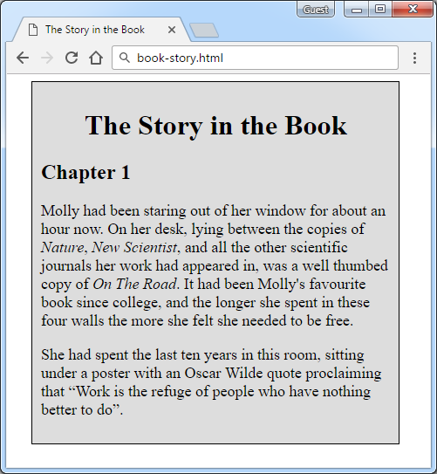

Create two files: “**book-story.html**”and“**book-story.css**”

### Constraints

* **<div>** with **id=wrapper** as a **container**
  + Width container: **400px**
  + Background color: **#dddddd**
  + Border: **1px solid #000000**
  + Margin Left**: 20px**
  + Padding**: 10px**
* **<p>** tag for paragraph + **font-size: 18px**
* **<em>** tag for italic text

### Hints

Use:

* **<h1>** tagfor heading + **center the text**
* **<q>** tag for quotation text
  + **q::before {  
     content: open-quote;  
    }**
  + **q::after {   
     content: close-quote;  
    }**

## Innovation Cloud

Create a Web Page like the following.



Create two files: "**innovation-cloud.html**"and "**innovation-cloud.css**"

Use **Semantic HTML** to create the page

### Constraints

* **Problem 3 + Problem 4**
* **Footer**
  + **Background color: #000000;**
* Text in the footer
  + Text color: **#ffffff;**
  + Text size: **14px;**
  + Height: **80px;**
  + Line height: **80px;**
  + Margin: **0px;**
  + Use the **HTML entity** for the “Copyright” character “**©**”.

## Conference

Create a Web Page like the following.

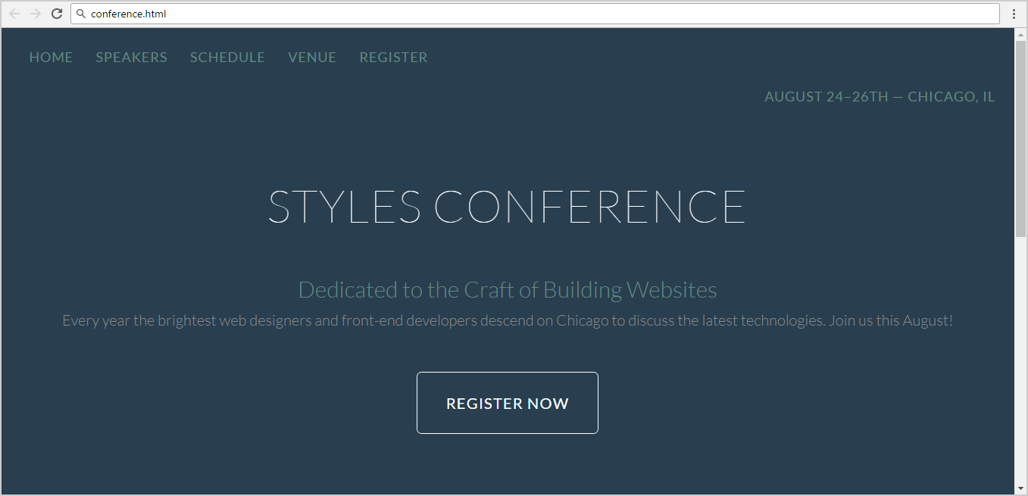

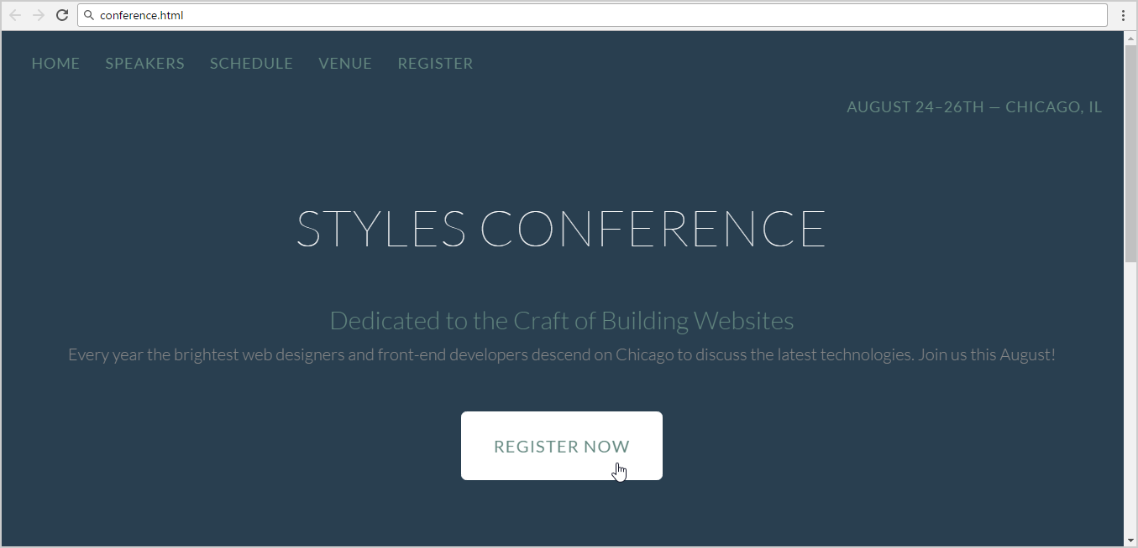

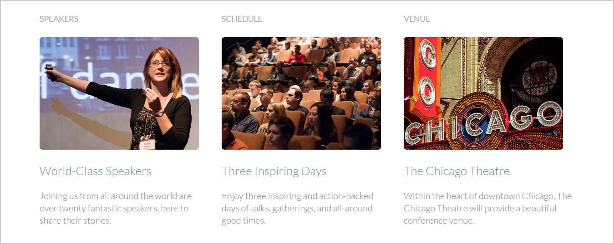



Create two files: "**conference.html**" and "**conference.css**"

Use **semantic HTML** to create the HTML page.

### Hints

* You may use **color picker** software ([search in Google](https://www.google.bg/search?q=color+picker+software)) to select the color of certain screen pixel.
* Use a hyperlink for the **button**.
* Get the “Lato” font from: <http://fonts.googleapis.com/css?family=Lato:100,300,400>.
* Default font: **300 16px/22px "Lato", sans-serif**

## World Cup News

Create a Web Page like the following using **World**-**Cup-News.txt.**

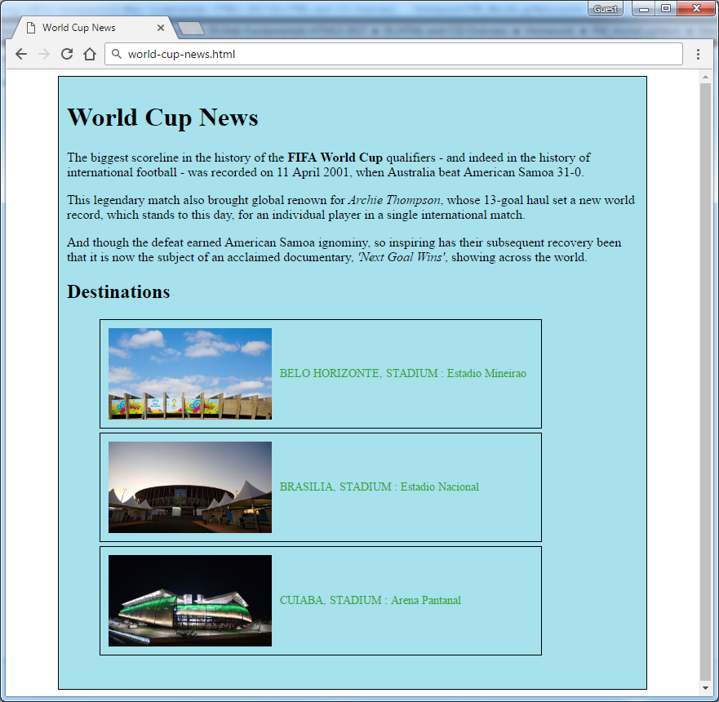

Create two files: “**world-cup-news.html**” and “**world-cup-news.css**”

### Constraints

* **<div>** with **id=** **"wrapper"** as a **container**
  + Width container: 700px
  + Height container: 730px
  + Border: 1px solid #000000
  + Center the **container**
  + Padding**:** 10px
  + Background color: #a6e1ec
* <h1>and<h2>tags for headings
* <p> tag for paragraph
* <strong>tag for **bold** text
* <em>tag for **italic** text
* <img> tag for images
  + Width: 200px
  + Margin Right: 10px
  + Vertical Align:middle
* <span class= "text">for the text next to images
  + Text color: #2EA620
* <li>tag
  + Width: 520px
  + Padding: 10px
  + Margin Bottom: 5px
  + Font Size: 14px
  + Border: 1px solid #000000

## Book Store

Create a Web Page like the following.

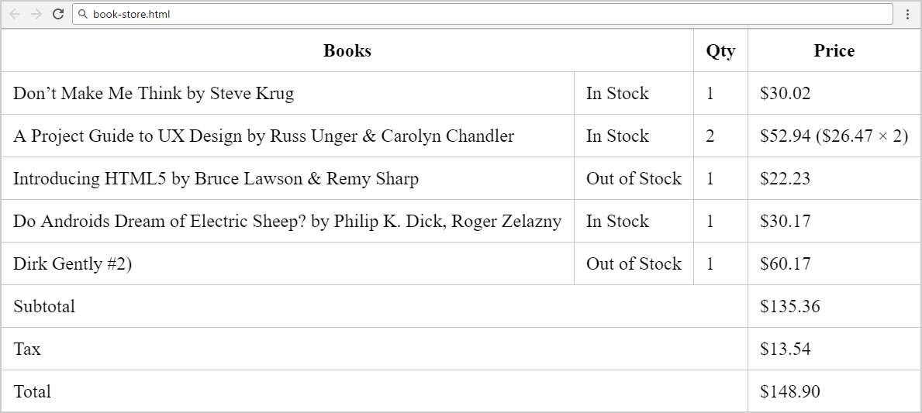

Create two files: "**book-store.html**" and "**book-store.css**".

### Constraints

* **Merge columns** in several table rows by using “colspan”.
* Table border color: #c6c7cc.
* Apply **padding** for all **table cells**.
* **Collapse** table borders to remove the empty space between the cells: <https://css-tricks.com/almanac/properties/b/border-collapse/>.

### Hints

Use:

* First reset the CSS styles.
* Use **&#8217;** for the **apostrophe**.
* Search Internet for **currency symbol HTML entiities** and other special symbols like **&**.